Worksheet 6

Background to flooding in the Cowbridge area

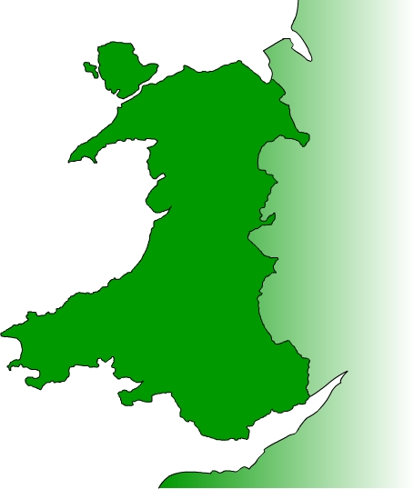
Cowbridge is a market town with a population of some 15,000 people. Llanblethian is a small village community centred around two bridge crossings of the River Thaw.

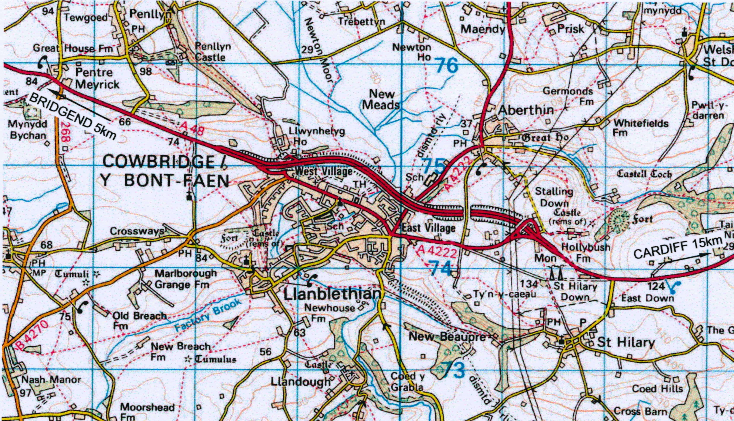

(Reproduced with permission of Ordnance Survey licence AL100018516)
History of flooding
Llanblethian has flooded 14 times in the last 80 years and 5 times since 1992, in November 1992, January 1994, and January 1995 and twice in October 1998. Cowbridge is not subject to such frequent flooding as Llanblethian. However, on the 31st October 1998, after a rainstorm of 13mm/hr intensity, flood waters entered a number of commercial properties.

Accounts of the 1998 flood can be found in the file Worksheet 6a
The current threshold of flooding has been identified as 1 in 11 years for Cowbridge and 1 in 3 years for Llanblethian.
Table 1 – Range of Properties Affected by Flooding
Type | Number | Details
Cowbridge
Agriculture | 0 | -
Commercial | 53 | Predominantly High Street shops
Public | 2 | Town Hall; public conveniences
Residential | 67 | Including 40 properties in Middlegate Court
Major infrastructure | 1 | High Street
Llanblethian
Agriculture | 0 | -
Commercial | 0 | -
Public | 0 | -
Residential | 31 | Predominantly located in Piccadilly and Greenfield Way
Major infrastructure | 2 | Local roads ‘Broadway’, ‘Bridge Road’ and ‘Piccadilly’

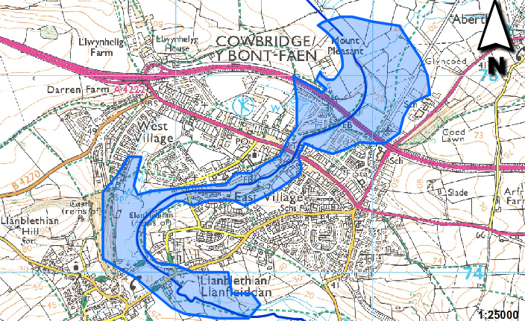
Image produced from the Ordnance Survey Get-a-map service. Image reproduced with kind permission of Ordnance Survey and Ordnance Survey of Northern Ireland

Existing Flood Defences
There are no formal flood defences on the River Thaw within Cowbridge and Llanblethian. However, some protection is afforded by the natural reduction of floodwaters within the Newton Moor flood plain upstream of Cowbridge, and on a small water meadow to the north of Llanblethian.

Causes of Flooding
Refer to the file Worksheet 5 Flood Hydrographs, Investigation which contains a map of the upstream areas of the R Thaw.
Further factors to those that can be determined from the map, are the poor channel capacity and the construction of bridges with limited conveyance [do not allow high discharge]. The inadequate capacity of the drains and overland flow also contribute to the flooding.

Other Issues

Flooding in the two communities is expected to become worse with time.
In addition to the direct effects of flooding, there are many secondary impacts which may be summarised as follows:
- Public transport problems and traffic disruption through Cowbridge town centre.
- Loss of business and trade with people unable to reach the town centre, and possible relocation of businesses affecting the local economy.
- Social impacts as people cannot reach workplaces.
- Reduction in property value, with increased insurance premiums or insurance refusals.
- Stress and emotional upheaval due to the loss of or damage to property of sentimental value.
- Ongoing worries and concerns related to the risk of being flooded.

